Siege of Fort Erie Reenactment Participant Package

Dear Reenactor:

Preparations for the Annual Siege of Fort Erie are well underway. The Siege of Fort Erie will take place on August 8 and 9, 2026.

Registration:

Please complete your unit registration online by July 31st to ensure space and food is reserved for each member of your group. Only one registration per unit is necessary. Please be prepared with amount of people attending and the sizes of the tents being brought along with the insurance policy number. Updates are allowed – please indicate an update in comment section or email me directly with any updates.
All individual participants must fill out a Volunteer Release Form upon arrival. Check-in and registration will be available at the Fort Visitor Centre Friday 1 p.m. to 8 p.m. and Saturday 10 a.m. to 12 noon.
Provided:

We will be supplying breakfast on both days (Saturday and Sunday), firewood, and limited black powder for artillery only. Please note that straw hasn't been ordered due to fire safety concerns in the camp and is not available. Potable water access point will be set up along with portable toilets in camp in addition to the ones located in our Welcome Centre which will be accessible overnight. Showers are limited (1 per washroom) and will be unlocked only while the fort is closed to the public.
Participants will receive a 20% discount on items in the Gift Shop and Snack Bar. Please identify yourself at the time of purchase if you or your family are not in period dress. For the Siege of Fort Erie Reenactment, bottled water and musket ammo will be provided Saturday Evening for participants assisting with the candle-lit tours.
US Travellers:
For our American friends, we would advise you to cross into Canada at The Peace Bridge, Buffalo/Fort Erie. We will contact Canada Customs in Fort Erie and this letter of invitation should assist your crossing. If travelling from the U.S. be advised that you will need a passport, please contact your local representative for information. There is no fee for flintlock firearms crossing the border, but they must be declared.

Artillery and Infantry:

The age for handling black powder is 16. All firearms, artillery pieces and implements will be inspected by site staff before they can be used for demonstrations. Copies of the site’s Participant Guidelines and Field Safety Rules are attached and will be available at the event and online.
Please ensure all unit members are aware of these safety rules. Any cannon barrel under 3' or 90 cm in length and with a carriage with less than 2' or 60 cm of clearance, unless designated a mortar or howitzer, cannot be guaranteed a spot in the artillery lines. If you have any questions or concerns, please contact Jim Hill or Erin Ronfeld before packing up with all your kit.

Parking:
Re-enactor parking is available in the lot on Dominion Road (please be courteous to our neighbours and their driveway) and off the Recreational Trail, on the East side of Lakeshore Road. Reenactor parking will be first come, first served. NOTE: some of the parking lot on Lakeshore Road is an archaeological dig and is fenced off.

Merchants:

The Historic Merchants are required to work in period clothing, in proper period tentage and sell only related items i.e. 1800 – 1815.The space that you have rented is for your company or group only. Each merchant’s space will be indicated by spray paint or markings on the ground according to the measurements you provide. Please strictly observe these markings and please work with your neighbours to ensure that these boundaries are respected.

Please help us in maintaining the quality of this event by displaying and selling only items that are historically accurate and/or relate to the period. If you are asked by designated staff to remove an inappropriate item, please comply. If you chose not to maintain period merchant status you will be asked to leave the event and invoiced as a modern vendor. The fees for modern vendors start at
$300.00.

The sale of any item acquired by archaeological excavation or pirated copies are strictly prohibited.

Historic Merchants are required to pay a fee of $50.00 which is payable at the time of your arrival in the Gift Shop. If you are a craftsperson whose activity is demonstrating only, the fee is waived. If there are any questions regarding this matter, please feel free to contact me.
When registering please indicate the exact space required including tent ropes, displays, firepits etc. We will try to accommodate everyone’s needs and requests as best we can but there is a limited space with shade and approximation to washrooms. Thank you for your patience and understanding as we work with you to try to accommodate everyone as best we can.

Contact:
We are looking forward to seeing you this campaign season.

Erin Ronfeld  Manager, Old Fort Erie (905) 871-0540  eronfeld@niagaraparks.com | Drew Neufeld  Assistant Manager, Old Fort Erie (905) 871-0540  dneudeld@niagaraparks.com | Jim Hill  Senior Manager, Heritage (905) 658-5390  jhill@niagaraparks.com

Participation Guidelines

- Everyone must check in at Registration upon arrival. Camp locations are pre-determined and must be followed to allow room for everyone. Every adult must sign an individual release from liability form.
- Old Fort Erie’s hours of operation are 10:00 a.m. to 5:00 p.m. and we ask participants to have their area open to the public during these times. No anachronisms are allowed in
front of the public and we ask that you explain to the visitors your uniforms and equipment. Many visitors indicate this is the highlight of their visit to the event.
- Equipment, black powder and firearms are the responsibility of each unit and must not be left unsecured or unguarded. Firing is only allowed in designated range areas. Time in the powder lab can be arranged for artillery or musket ammunition preparation.
- Every unit commander briefing must be attended by a unit representative. Every unit member must read the site safety rules for the handling of firearms and black powder.
- This is a family event and please, no consumption of alcohol is allowed during open hours. Late night noise or disorderly conduct will not be tolerated and those involved may be asked to leave by site staff or police.
- Firepits will be designated by site staff, please ask where you can place your unit’s firepit. Simply turn the sod, please don’t dig, fires must be limited to a size for cooking and must not be left unattended. Each fire must have water buckets. Please turn the sod back before leaving the event.
- First aid kits, firefighting equipment and emergency phones are in the Fort and Welcome Centre. Please inform site staff of any requirements.
- If you require use of a fridge to store medicines, or an outlet to charge sleep apnea machines, please see Welcome Centre Staff or contact the manager to give you access to those spaces. We want to ensure everyone is welcome at this event and are here to assist those with medical devices or needs if we are able.
- Vehicles are allowed into the period camp for unloading and loading. Please keep streets in the camp clear for maintenance and emergency vehicles. Cars will be ticketed and/or towed. For emergency access - parking on Lakeshore Road is only allowed on the east/riverside.
- Selling items from anywhere other than Merchant Row and without paying the merchant fee is prohibited.
- Site staff will be on duty throughout the event. After hours the manager is available in the Welcome Centre. If there is an emergency, do not hesitate to call 911.
- Reenactor parking will be available in the Lakeshore Rd parking lot, the Dominion Road main lot, and in the subdivision surrounding the fort on one side of the street (marked). If parking in the neighbourhood, please keep our neighbours happy and do not block entrances or driveways.
To make this a safe, enjoyable experience for all, we ask your cooperation with:

- Pets must be always kept on a leash. Please be a responsible pet owner and clean up after your animal.
- Children must always be under the direct supervision of a parent or responsible adult. Children under 16 without adult accompaniment are not allowed in the Fort.
- Registered participants welcome into the Fort free of cost if in period costume. Shoes must be always worn in the fort.
- Firewood provided by the site is for everyone. Be considerate of fellow participants and take firewood only as needed.

Niagara Parks Commission – Field Safety Rules

All participants, including non-combatants, should read these field safety rules. Attendance by a Unit Representative at all safety briefings and walk-throughs is compulsory. Any unit that is not represented will be asked to stay in camp.

Black Powder

- Black powder must be kept a minimum distance of eight (8) metres/yards from open fires.
- When not in use powder must be secured and out of the reach of children or visiting public.
- Any theft of black powder should be reported to site staff whether actual, suspected or attempted.
- Preparation of ammunition should be done before arrival. Unit members will remove wool coats and period footwear when preparing charges in the fort powder lab.
- Participants under 16 years of age will not handle black powder.
- If disposal of black powder is necessary, it is to be done by designated site safety staff.

Firearms

- Only proofed reproduction firearms can be used.
- All ammunition and firearms will be subject to examination by designated site safety staff.
- All firearms should be in proper working order and have a functioning half-cock mechanism.
- No firearm, loaded or unloaded, shall be pointed towards another person.
- No member of the public (including press) shall handle a firearm, loaded or unloaded.
- All firearms must always be secure, either held in hand or locked away.
- Any necessary licenses or permits should be readily available.

Edged Weapons

- All edged weapons including bayonets, knives, swords, tomahawks, etc., must be sheathed on the field except for approved weapons during demonstrations with no opposing sides.
- No edged weapons may be thrown at any time except for approved weapons during demonstrations with no opposing sides.

Tactical Demonstrations/Simulated Battles

- The safety of the viewing public and reenactors is paramount and will be the determining factor in the location and extent of demonstrations.
- For public safety, caution tape and barriers establish viewing lines.
- Any person found violating stated rules and regulations will result in his/her immediate expulsion from the site during the remainder of the program.
- Any unit that does not abide by the rules or cannot control their unit members will be removed from the program and will not be invited to future re-enactments at the site.
- NO firing of small arms, in any direction, within six (6) metres/yards of viewing lines.
- NO firearm or artillery piece is to be discharged towards or over viewers.
- NO participant will cross viewing lines during demonstrations.
- ALL unit commanders must clear and safety check their unit’s firearms before leaving a demonstration area. All units must check their area for cartridges and percussion caps.
- The command STOP will halt marching, loading and firing until cleared by site safety staff to continue.

Infantry

- During any opposed side demonstration, firearms will not be deliberately aimed at ‘enemy forces’, regardless of distance/range to the opposing line.
- Ramrods are not to be used at any time during a tactical demonstration. At the beginning and end of a demonstration they will be used to ensure the firearm is unloaded.
- Muskets must use black powder in pre-measured paper cartridges. Loading from a powder horn is not permitted. Revolver chambers should be pre-loaded, and reloading will be done with paper cartridges.
- No projectile, including wadding, may be fired from a musket at any time.
- No demonstration of rapid fire will be permitted.

- Firing will cease within twenty-five (25) metres/yards of two units and no closing with edged weapons is allowed. Any closing must be pre-determined with opposing force commanders and site staff.
- After three (3) misfires, powder will be dumped from the barrel of a muzzleloader before another attempt.
- Firearms will be unloaded - fired or the powder dumped - before crossing obstacles.
- Frizzen covers (hammer stalls) to prevent accidental discharge are recommended. Flashguards fitted to priming pans are strongly recommended. Earplugs are strongly recommended.
- Infantry will stay a minimum distance of fifty (50) metres/yards from firing artillery. Infantry will not advance on a gun position with a misfired artillery piece.

Artillery

- All loading and firing intervals will be confirmed by the site safety staff. A five-minute loading interval will be the minimum standard.
- All artillery blank charges will be made of aluminum foil, rolled and formed with a distinct bottom and top, filled with black powder and no wadding.
- Ear plugs and gloves are strongly recommended.
- Each artillery piece, its implements and the gun detachment drills will be inspected by site safety staff.
- Detachments will double worm and double sponge for all blank firings.
- Artillery pieces will be spaced a minimum of five (5) metres/yards from hub to hub.
- Artillery will not be fired if there are any re-enactors within fifty (50) metres/yards of the muzzle, inside a left and right arc of thirty (30) degrees (550 mils), from the rear of the artillery piece.
- Ammunition in a self-closing munitions box will be kept within the safety arcs at the rear of the piece.
- Artillery will be placed a minimum of twelve (12) metres/yards in front of or to the side of the public.
- Loaded artillery pieces will not be moved.
- Any misfire will be cleared in place and no attempt to re-ram will be allowed. Once all evidence of smoke is clear, a minimum of 5 minutes will be observed, and the detachment will be given the opportunity to prime and attempt firing a second time. No third attempt will be permitted. The artillery piece is out of action and will be cleared in place after the tactical demonstration.

Recommendations For Gunners - Spare firing implements and equipment. Charge form fit to the breech of your piece. Flashlights for night firing. Appropriate clothing and footwear for work in powder lab (i.e. small clothes and rubber soled shoes). Gun drill will be assessed for safety and not precision appearance.

First Aid

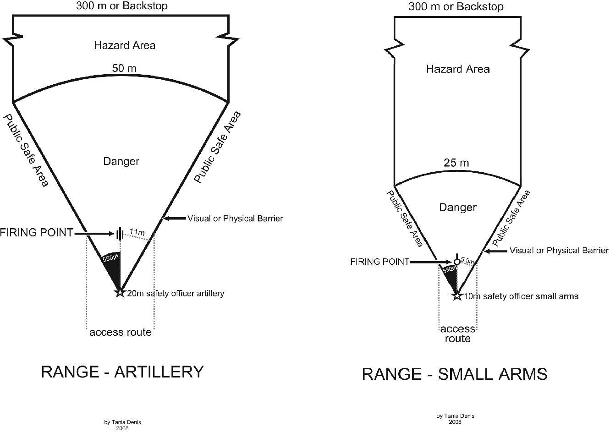
Trained site staff are on and around the field with water and first aid kits, they will be identified by armbands. Safety access routes will be indicated. If you are a medical or emergency professional, it would be helpful if you identified yourself at registration or officer call.

